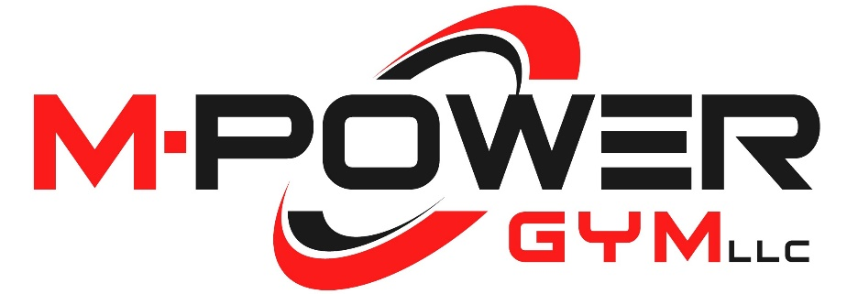
DO YOU WANT TO ADVERTISE IN NORTH DAYTON’S NEWEST BOXING, STRENGTH, SPORTS PERFORMANCE, AND MARTIAL ARTS FACILTY???
THIS IS YOUR OPPORTUNITY!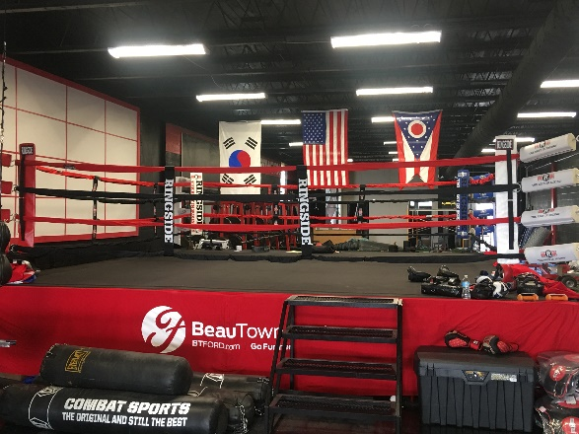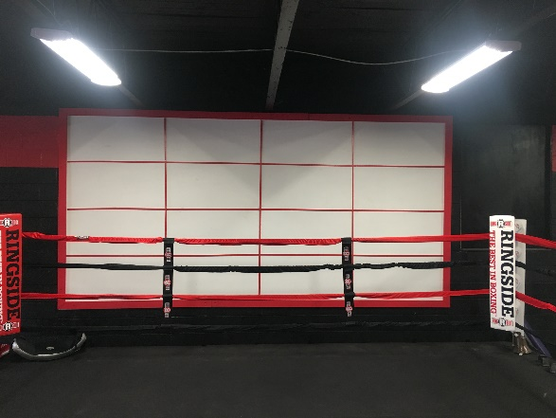
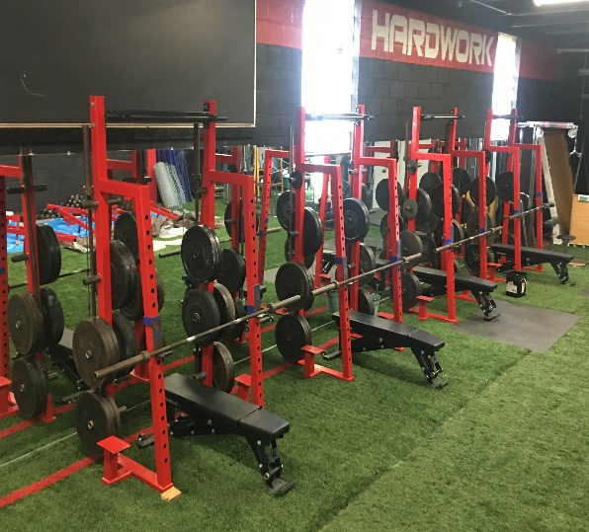
PRICING: 1 YEAR $350, 5 YEAR $1000
Contact M-POWER GYM for more details @ 937-529-9072 mpowergymllc@gmai.com
Ask for Will Ashcraft or Mike Baker (Owners)
270 N DIXIE DRIVE VANDALIA, OHIO 45377

